|  |  |
| --- | --- |
| 26 /08/ 2021 | FAMILIRIZATION OF CONSOLE I/O AND OPERATORS IN C  i)Display “Hello World”.  ii)Read two numbers ,add them and display their sum.  iii)Read the radius of a circle, calculate its area and display it.  iv)Evaluate the arithmetic expression ((a-b/c*d+e)*(f+g)) and display its solution .Read the values of the variables from the user through console. |
| EXP.NO. 3 |

AIM:

Print Hello World.

ALGORITHM:

1.START

2.Print Hello World.

3.STOP.

PROGRAM:

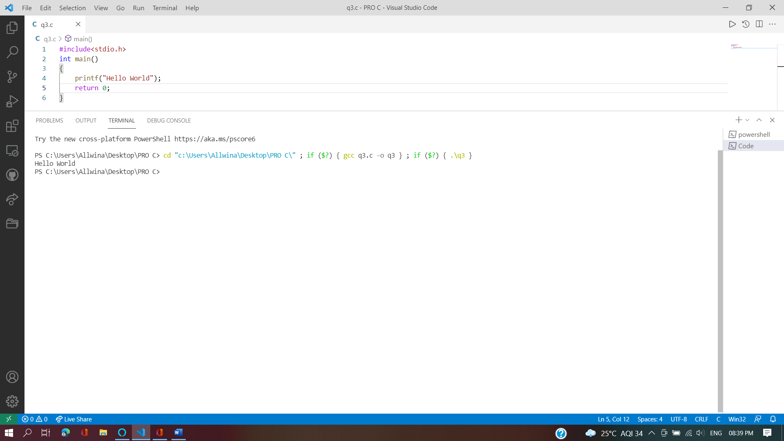

OUTPUT:



RESULT:

The program to print Hello World has been implemented and the output is verified.

AIM:

To add two numbers.

ALGORITHM:

1.START

2.Input the values of two numbers as a and b.

3.Print the sum as a+b.

4.STOP.

PROGRAM:

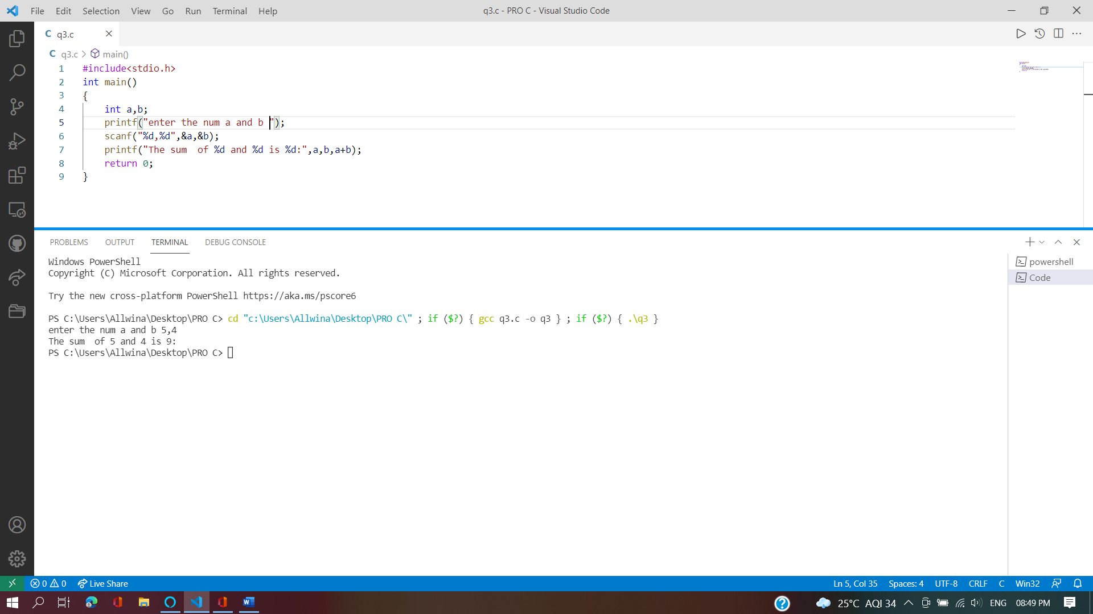

OUTPUT



RESULT:

The program to add two numbers has been implemented and the output is verified.

AIM:

To read radius ,calculate and display the area of the circle.

ALGORITHM:

1.START

2.Read radius as r.

3.Calculate area by 3.14xrxr.

4.Print the area.

5.STOP.

PROGRAM:

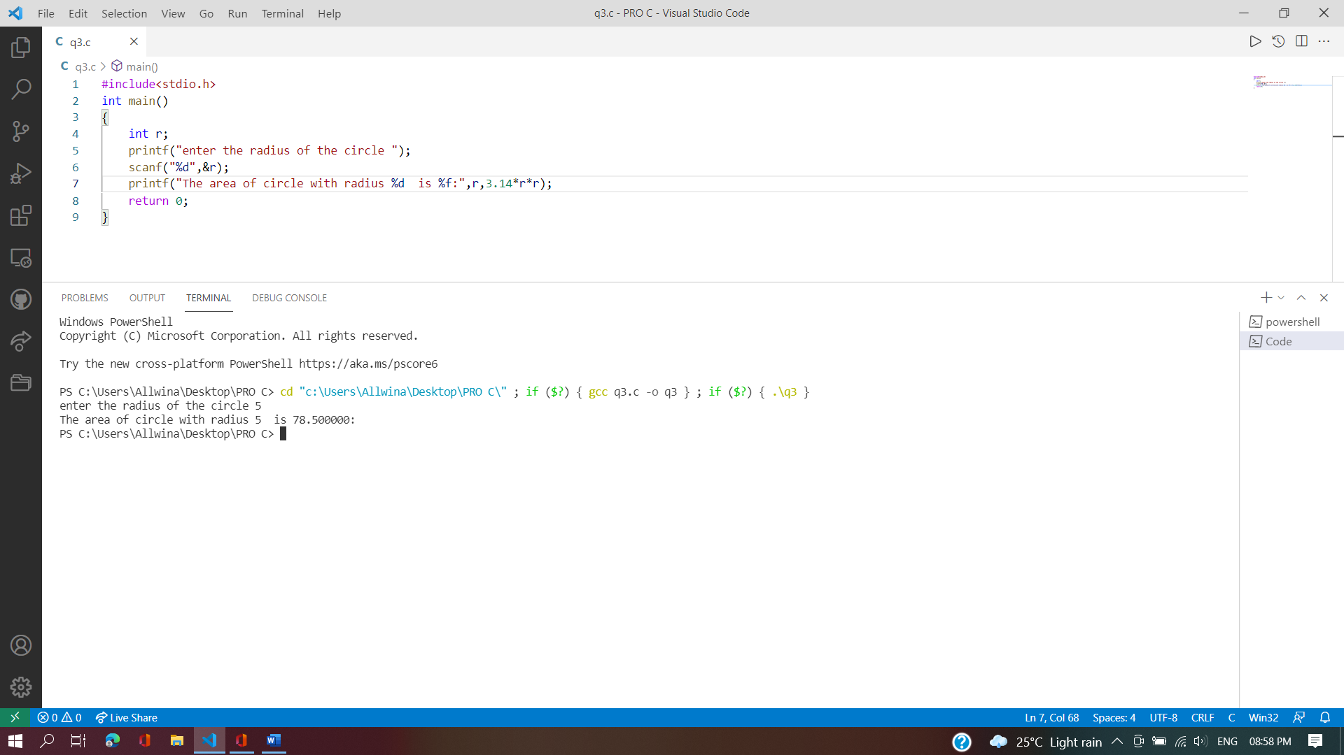

OUTPUT:



RESULT:

The program to read radius ,calculate and display area of a circle has been implemented and the output is verified.

AIM:

To evaluate and display the solution of the arithmetic expression ((a-b/c*d+e)*(f+g) by reading the variables from the user.

ALGORITHM:

1.START.

2.Initialize a,b,c,d,e,f,g,v.

3.Read the values of a,b,c,d,e,f,g.

4.Calculate the algebraic equation ((a-b/c*d+e)*(f+g) and equate it to v.

5.Print the value of v.

6.STOP.

PROGRAM:

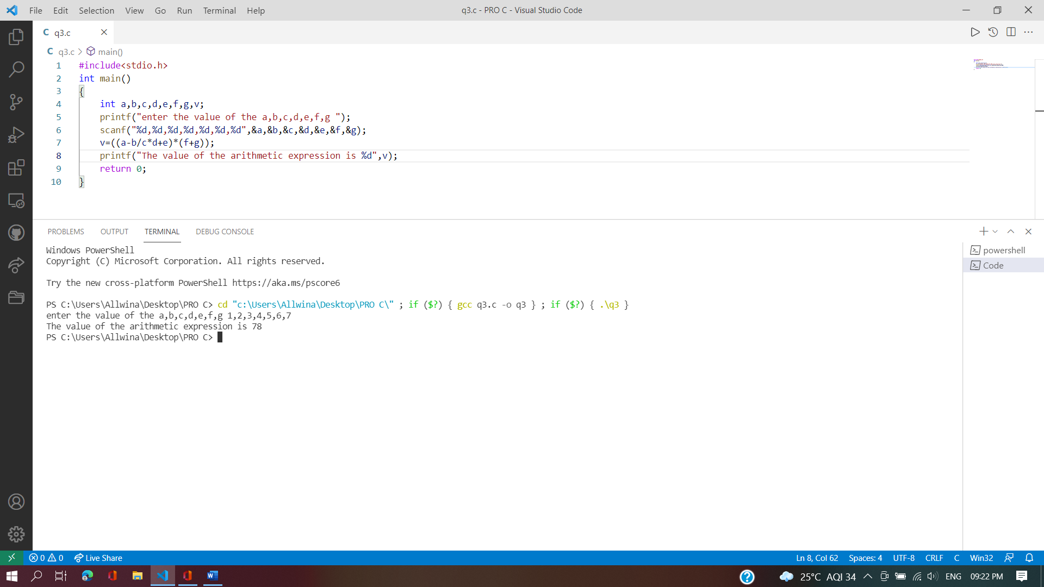

OUTPUT:



RESULT:

The program to evaluate and display the solution of the arithmetic expression ((a-b/c*d+e)*(f+g) by reading the variables from the user has been implemented and the output is verified.